pe

Proposal
to
Ministry of Electronics & Information Technology,
Govt. of India

for

Skill Development of Unemployed Youths of Odisha, Jharkhand, West Bengal, and Bihar for Enhancing Employability and Enabling Entrepreneurship Towards Sustainable Development of States

by

National Institute of Electronics & Information Technology,

NIELIT Bhawan,
Plot No. 3, PSP Pocket, Sector-8,
Dwarka, New Delhi-110077,
Phone:- 91-11-2530 8300
Website: www.nielit.gov.in

Project Proposal

Title of the Project
Skill Development of unemployed youths of Odisha, Jharkhand, West Bengal, and Bihar for enhancing Employability and enabling Entrepreneurship towards Sustainable Development of States.

Organization

- NIELIT Bhubaneswar
  - Name : National Institute of Electronics and Information
Technology (NIELIT), Bhubaneswar
  - Postal Address : 3rdFloor, OCAC Tower, Acharya Vihar, Bhubaneswar-751013
  - Contact Numbers & Email : 0674- 2960354, dir-bbsr@nielit.gov.in
  - Legal Status : An Autonomous Scientific Society under Ministry of Electronics and
Information Technology, Government of India
- NIELIT Ranchi
  - Name : National Institute of Electronics and Information
Technology (NIELIT), Ranchi
  - Postal Address : 2nd Floor, RIADA Bhawan, Main Road, Ranchi-834001.
  - Contact Numbers & Email : 0651-2332554, dir-ranchi@nielit.gov.in
  - Legal Status : An Autonomous Scientific Society under Ministry of Electronics and
Information Technology, Government of India
- NIELIT Kolkata
  - Name : National Institute of Electronics and Information
Technology (NIELIT), Kolkata
  - Postal Address : Jadavpur University Campus, Jadavpur, Kolkata 700032
  - Contact Numbers & Email : 033 2414 6054/81, dir-kolkata@nielit.gov.in

- NIELIT Patna
  - Name : National Institute of Electronics and Information
Technology (NIELIT), Patna
  - Postal Address : Near IIT Patna, Amhara, Bihta, Patna(Bihar)-801106.
  - Contact Numbers & Email : 06115-235318, dir-patna@nielit.gov.in

Details of Chief Investigator & CO CI’s

Chief Investigator
Name | Shri Jayanta Chakarborty
Designation | Director in –charge
Address | NIELIT Bhubaneswar,3rd Floor,OCAC Tower,Acharya Vihar,Bhubneshwar -751013
E-mail ID ,Phone Number& Mobile | dir-bbsr@nielit.gov.in, 0674-2960354,983631064
CO-CI
Name | Shri Sh.Ashish Mathur
Designation | Scientist –D
Address | NIELIT BHUBNESHWAR,3rd Floor,OCAC Tower,Acharya Vihar,Bhubneshwar ,Odisha-751013
E-mail ID & Mobile | ashishmathur@nielit.gov.in, 8317093871
CO-CI
Name | Shri. B.N Singh
Designation | Scientist –D
Address | NIELIT PATNA,Near IIT PATNA,Amhara,Bihar,Patna(Bihar)-801106
E-mail ID & Mobile | bnsingh@nielit.gov.in, 8317093879
CO-CI
Name | Dr. Kalyan Baital
Designation | Scientist -D
Address | NIELIT kolkata, Jadavpur University Campus, Jadavpur, Kolkata 700032
E-mail ID & Mobile | kbaital@nielit.gov.in, 9073304897
CO-CI
Name | Shri J.K Shah
Designation | Director in-Charge /Scientist -D
Address | NIELIT Ranchi, 2nd Floor, RIADA Bhawan, Main Road, Ranchi- 834001
E-mail ID & Mobile | jksah@nielit.gov.in, 9417513809

Nature of the project

IECT Skill Development : Yes
Infrastructure Development : No

Project Objective

The Objective of the project is to conduct free Skill Development programme of 50040 (12,510 in each state) youth with about 35,028 SC/ST youths (SC/ST 8,757 in each state) and 15,012 youths (3753 in each state) of General- EWS categories over a period of 3 years to enhance employability and enable entrepreneurship towards sustainable development among youths of Odisha, Jharkhand, West Bengal and Bihar by providing skill development in various NSQF aligned courses under IT and Electronics domain.

GIA from MeitY has been sought to uplift youths of the deprived classes of the society. It is expected that about 70% SC/ST candidates will join the program and remaining 30 % will be from the General-EWS category. Effort will be made to target minimum 30% women. However, the targeted SC/ST candidates may increase or decrease and in such a situation, remaining candidates will be covered up from the other categories and vice-versa. Re-appropriation of targets under SC, ST and General-EWS category will be done at any stage of the project implementation. District wise and course wise may also be re-appropriated if required.

Outcome of the Project

Unemployed youths of Odisha, Jharkhand, West Bengal, and Bihar will be skilled in the following trades / courses for better employability and creation of entrepreneurs. The courses have been identified with current & upcoming demand. However, in case of demand of new courses or any changes in current courses, the targets may be re-appropriated within the funds allocated. In such cases, based on the needs of industry, new courses with similar duration will be taken from bucket of NSQF aligned NIELIT courses.

For Each District
Table -I
Sl No | Name of the Course | Course Duration in Hours | Minimum Eligibility | NSQF Level | Year 1 | Year 2 | Year 3 | Total Candidate
1 | Product Assembly Assistant (Solar-LED) | 330 | 10th / ITI / 12th/ Polytechnic Diploma | 3 | 80 | 80 | 80 | 240
2 | O Level (IT) | 540 | 12th OR 2ndyr Polytechnic Diploma OR 10th + 2 yr ITI OR 10th + 1 yr ITI with 1 yr exp. OR Gradation | 4 | 30 | 30 | 30 | 90
3 | Foundation course in Machine Learning using Python | 90 | 12th or 2nd year polytechnic diploma or 10th +2-years ITI or10th-1-year ITI with 1 year experience or Graduation | 4 | 190 | 190 | 190 | 570
4 | Foundation course in Internet of Things(IoT) | 90 | 12th or 2nd year polytechnic diploma or 10th +2-years ITI or10th-1-year ITI with 1 year experience or Graduation | 4 | 120 | 120 | 120 | 360
5 | Certified Computer Application Accounting and Publishing Assistant | 360 | 10th OR 8th& pursuing continuous regular schooling OR 8th +2 Years ITI OR 8th +1 Yr exp. | 3 | 70 | 70 | 70 | 210
6 | Certified Web Developer | 210 | 12th OR Final-year Polytechnic Diploma in CS/IT OR 10th + 2-Year ITI in IT/ITeS | 3 | 80 | 80 | 80 | 240
7 | Certified Data Entry and Office Assistant (Upskilling) | 210 | 12th OR Polytechnic Diploma (passed/final yr) OR 10th + 2 Year ITI OR 10th + continuing regular Education OR 8th & 2 Years ITI with 2 Year Exp. | 3 | 120 | 120 | 120 | 360
8 | Foundation course in Information Security | 90 | 2nd Year Polytechnic Diploma in Computer  Science/ IT/ Electronics /Electrical/  Instrumentation/  or  Final year BCA/B.Sc.(Electronics/CS/IT)  or  Pursuing MCA/MSC(CS/IT) /PGDCA  or  Pursuing B.E/B.Tech in any domain  or  NIELIT O Level(IT) | 2 | 144 | 144 | 144 | 432
Total candidates Per district  (district may have multiple training centres) |  |  |  |  | 834 | 834 | 834 | 2502
No of districts in Odisha: 5, Total in Odisha |  |  |  |  | 4170 | 4170 | 4170 | 12510
No of districts in Jharkhand: 5, Total in Jharkhand |  |  |  |  | 4170 | 4170 | 4170 | 12510
No of districts in West Bengal: 5, Total in West Bengal |  |  |  |  | 4170 | 4170 | 4170 | 12510
No of districts in Bihar: 5, Total in Bihar |  |  |  |  | 4170 | 4170 | 4170 | 12510
Total Target in 20 districts of 4 states |  |  |  |  | 16680 | 16680 | 16680 | 50040
Total SC/ST Candidate (approx. 70%) |  |  |  |  | 11676 | 11676 | 11676 | 35028
General-EWS candidates (approx. 30%) |  |  |  |  | 5004 | 5004 | 5004 | 15012

*: Link to National Qualification Register for Detailed curriculum of the Courses proposed and the link of bucket of NIELIT NSQF courses is given at Annexure – I. Infrastructure required to conduct the practical/hands-on session for the above-mentioned courses given at Annexure-II. There will be 30 students in one batch. District wise and course wise batch details is given in Annexure III.

*Note:
a. The Title and Level of the above courses are subject to revision upon NCVET/ NSQC recommendation
b. Courses from the above bucket may be added/deleted/replaced at any point of time keeping industry and employability requirement in view or as per the suggestion/recommendations of expert committee set up by MeitY, However notional hours will be maintained to maintain the over all budget outlay of the project

Selection of Districts/ Locations:

Skill Development programme has been proposed to be conducted in 5 districts each of Odisha, Jharkhand, West Bengal, and Bihar for 3 years, based on remoteness & backwardness. The locations are covering all parts of the states from North to South and East to West. Most of these areas are untouched areas of NIELIT & other similar organizations. Candidates of adjoining districts will also be benefitted, as movement of candidates in the boundary of these districts is quite apparent. However, to achieve the total target allocated in a state, new districts can be added keeping the above-mentioned criteria into the consideration.

Skill Development Institutes:

Preference will be given in following order:

- NIELIT own centre/extension centres in all four states.

- Wherever infrastructure and equipment and other necessary resources are made available from the Polytechnics/ ITI/ State Government Organization/Department/ Institutes, the Skill Development training may be imparted by utilizing their resources as far as possible.

- In case, at any location required infrastructure/ equipment’s are not available for implementation of the project or required for other scheduled activities, NIELIT accredited instituitons will be explored.

- In case of non availability of NIELIT Accredidated instituions , NIELIT may also explore the possibilities of having tie up with new institutions (private) to achieve the target.

In case of point 2, 3 and 4 above the arrangements will be done through an agreement on mutually acceptable T&C.

Quantifiable Deliverable of the Project

For Odisha State
Table -II
SN | District | Geographical location in the state | Proposed Skill Development location / Skill Development Location | No. of Candidates to be Skilled in 3 years
1 | Khordha | East-Central | NIELIT Bhubneshwar and its associated Training partners (Polytechnic/ITI/Accredidated Instituions/Other private institutes) | 2502
2 | Jagatsinghpur | East | Govt Industrial Training Institute/ Polytechnic, Jagatsinghpur | 2502
3 | Balasore | North East | Govt Industrial Training Institute/ Polytechnic, Balasore | 2502
4 | Ganjam | South East | Govt Industrial Training Institute/ Polytechnic, Ganjam | 2502
5 | Naupada | West | Govt Industrial Training Institute/ Polytechnic, Naupada | 2502
Total |  |  |  | 12510
SC/ST Candidate (approx. 70%) |  |  |  | 8757
Other Than SC/ST candidates (approx. 30%) |  |  |  | 3753

For Jharkhand State
Table -III
SN | District | Geographical location in the state | Proposed Training location / Skill Development Location | No. of Candidates to be Skilled in 3 years
1 | Seraikela Kharsawan | East-Central | Government Polytechnic, Seraikela  Govt. ITI, Seraikela  Govt. Women Polytechnic, Gamharia | 2502
2 | Simdega | South | Govt. Polytechnic Simdega  Simdega College Simdega  Womens College Simdega  Govt. Industrial Training Institute, Simdega | 2502
3 | Deoghar | North-East | Govt Polytechnic Deoghar  Deoghar College Deoghar  Deoghar Govt. ITI College, Jasidih, Deoghar | 2502
4 | Koderma | North | Govt Polytechnic Koderma  Govt. Engineering College, Koderma  Govt Industrial Training Institute, Koderma | 2502
5 | Chatra | North | Govt Polytechnic Chatra  Govt Industrial Training Institute, Simaria, Chatra | 2502
Total |  |  |  | 12510
SC/ST Candidate (approx. 70%) |  |  |  | 8757
Other Than SC/ST candidates (approx. 30%) |  |  |  | 3753

For West Bengal State
Table -IV
SN | District | Geographical location in the state | Proposed Training location / Skill Development Location | No. of Candidates to be Skilled in 3 years
1 | Birbhum | South-West | Govt Industrial Training Institute/ Polytechnic, Birbhum | 2502
2 | Purulia | West | Govt Industrial Training Institute/ Polytechnic, Purulia | 2502
3 | Howrah | South | Govt Industrial Training Institute/ Polytechnic, Howrah | 2502
4 | Maldah | Central | Govt Industrial Training Institute/ Polytechnic, Maldah | 2502
5 | Uttar Dinajpur | North | Govt Industrial Training Institute/ Polytechnic, Uttar Dinajpur | 2502
Total |  |  |  | 12510
SC/ST Candidate (approx. 70%) |  |  |  | 8757
Other Than SC/ST candidates (approx. 30%) |  |  |  | 3753

For Bihar State

Table –V
SN | District | Geographical location in the state | Proposed Training location / Skill Development Location | No. of Candidates to be Skilled in 3 years
1 | Gaya | South-Central | Govt. Polytechnic College, Gaya | 2502
2 | Rohtas | South-West | Govt. Polytechnic College, Dehri-on-sone | 2502
3 | Lakhisarai | South-East | Govt. Polytechnic College, Lakhisarai | 2502
4 | Motihari | North-West | Govt. Polytechnic College, Motihari | 2502
5 | Purnea | East | Govt. Polytechnic college, Purnea | 2502
Total |  |  |  | 12510
SC/ST Candidate (approx. 70%) |  |  |  | 8757
Other Than SC/ST candidates (approx. 30%) |  |  |  | 3753

Note:

Effort will be made for conduction of the training at NIELIT own centres/extension centre

If it is not possible to conduct the training at NIELIT own centres/extension centre, training will be conducted as per the serial no. 8. The centres are in the process of seeking support from the state government and it is expected to receive very soon.

Duration of Project:

3 Years

Year-wise break-up of physical achievements
Table -VI
Year | Year 1 |  |  | Year 2 |  |  | Year 3 |  |  | Grand Total*^^
 | SC/ST | General-EWS | Total | SC/ST | General-EWS | Total | SC/ST | General-EWS | Total | SC/ST | General-EWS | Total
Odisha State | 2919 | 1251 | 4170 | 2919 | 1251 | 4170 | 2919 | 1251 | 4170 | 8757 | 3753 | 12510
Jharkhand State | 2919 | 1251 | 4170 | 2919 | 1251 | 4170 | 2919 | 1251 | 4170 | 8757 | 3753 | 12510
West Bengal | 2919 | 1251 | 4170 | 2919 | 1251 | 4170 | 2919 | 1251 | 4170 | 8757 | 3753 | 12510
Bihar | 2919 | 1251 | 4170 | 2919 | 1251 | 4170 | 2919 | 1251 | 4170 | 8757 | 3753 | 12510
Total Targeted No. of Candidates | 11676 | 5004 | 16680 | 11676 | 5004 | 16680 | 11676 | 5004 | 16680 | 35028 | 15012 | 50040

* Effort will be made towards achieving overall minimum 30% women intake.

^^ NIELIT Bhubaneswar, NIELIT Ranchi, NIELIT Kolkata, NIELIT Patna Centres will try to achieve the assigned target every year. In case, if in any particular year, actual achievement is higher / lower, the same will be rationalized in the allocation of next year. Further, the targeted SC/ST candidates may increase or decrease and in such a situation, remaining candidates will be covered up from the other categories and vice-versa to achieve the total target every year. To achieve the targets if required, the targets may be re-appropriated category wise, course wise and district wise from time to time as per requirement but within a state.

Name of the Agency or Organization Jointly Participating in the project

Please refer point 8.

Role of Agency or Organization Jointly Participating in the project

The resources both Manpower as well as Infrastructure from the Govt Depts./ Colleges/ Institutes / Industries / Accredited institutes/ Training partners/ Private organizations etc. may would be utilized during the implementation of the project for maximum participation of the students and also to give them an opportunity to acquire the skill during their study.

Implementation Strategy

Skill Development:

The NSQF curriculum for skill development training, assessment, and certification will be followed uniformly across the project, so that uniformity in respect of standard is maintained for all the districts of the four states identified under this project.

Coordination and Monitoring:

Director In-Charge, NIELIT Bhubaneswar would be the chief-investigator of the project supported by a coordination team and he will be responsible for overall management of the Project.

Co-chief investigators from each of the other state will also act as nodal officers for their state and would be responsible for the management of the project in the district(s) under their jurisdiction and as per the guidelines of the PMU to be formed for this purpose.

A Project Management Unit (PMU) will be set up at NIELIT Bhubaneswar. The main responsibilities of PMU are as follows:

PMU will issue necessary directives to nodal officers for conduction of training in states.

Development of dashboard and integration with MIS as per the requirement of the project

PMU will upload the status on NIELIT MIS portal also.

PMU will maintain record of all the financial and physical of the project

PMU will coordination with all stake holders to review the target achieved during a certain period.

To discuss the issues raised during review meeting and suggesting the appropriate action.

PMU will compile the reports received from all centres on monthly basis and will forward to Ministry for its perusal under intimation to NIELIT HQ.

Four NIELIT Centres (Bhubaneswar, Ranchi, Kolkata, and Patna) will be responsible for implementation of project in the states under their jurisdiction. All NIELIT Centres will cover its jurisdiction either by setting up temporary facilities or by enrolling training partners (TPs) preferably at government ITI/Polytechnic colleges. Effort will be made to tie up with Government for enrolling the TPs. In case of non-availability of such institutes, private institute will be mobilized for affiliation with NIELIT as TP. Co-Investigator at NIELIT Centre will submit physical & financial status of project to PMU at Bhubaneswar. The main responsibilities of the implementing centres are as follows:

Report to PMU

Maintaining records of training

Publicity of programme in their region.

Sole responsibility for implementation of programme in the state under the jurisdiction

Release of fund to TP

Conduct of training / awareness program at centre.

Conduct training program on need basis.

Outcome assessment

NIELIT HQ will review the outcome of the project time to time

The MeitY will approve the project and release GIA for the project and MeitY will constitute PRSG for the review and recommendations in r/o the project.

Expert Committee will also be constituted by MeitY preferably comprising of members from MeitY , NIELIT , Academia and Industry to review and suggest the course bucket time to time keeping notional hours of the course intact. Expert committee will function in parallel to PRSG.

Mobilization and Selection of Candidates:

Applications from interested candidates may be invited online along with publicity in regional or local dailies/ web-site/ direct counseling at educational institutions or names/list or data of candidates may be provided by Dept. of Social Welfare / Dept. of SC/ST Development/ Dept. of Women and Child Development of the concerned State Government / Local employment exchange etc. All these activities will be looked by Co-investigator of respective NIELIT Centre.

A three-member committee comprising of Co-investigator from NIELIT centre, head/authorized signatory of training partner and one members preferably from the concerned State Government / Local employment exchange or any other Officer nominated by District Authority may select the candidates fulfilling minimum eligibility criteria for admission as per qualification file of the course and on merit basis.

Registration of the candidate:

Registration for admission in any course for the shortlisted candidates will be preferably done through centralized portal of NIELIT. Registration will be done by the candidate and TC/TP will assist candidates in Registration. Opening of registration in any course will be notified on website /portal of NIELIT well in advance and also NIELIT centres will publicize the same. While admitting a candidate training partner will thoroughly check caste/EWS certificate, domicile certificate, educational qualification certificate, ID Proof and other necessary documents in person of every student in a batch.

Note: Admission in any course will be granted to registered students after due process of short listing / scrutiny by the three-member committee mentioned above.

Assessment & Certification:

Examination would be conducted as per norms and in such a manner so that all the candidates across all Skill Development Centres may acquire common competency. After completion of training, assessment will be carried out by Exam Wing NIELIT HQ as per the defined guidelines/norms of NIELIT. The NSQF certificate will be issued to the successful candidates appearing in NSQF examination and as per the standard procedure of NIELIT.

However, on completion of training, all participants will be eligible to get participation certificate which will be issued by respective NIELIT Centre.

Modular certificates will be provided for O level (IT) passed candidates. Cost if any will be borne by the candidate himself/herself.

Placement, Employment & Entrepreneurship:

All four NIELIT centres are having a Skill Development & Placement cell which is dedicated for the placement of candidates passing out from the institute. The cell has been instrumental behind creation of employment opportunities through regularly organizing campus/off-campus Placement drives/ Rojgar Mela for the students of NIELIT centres.

All four of the NIELIT Centres are proactively working with the office of Sub Regional Employment Officer, a local office of DGE and with the State Government Employment Exchanges for mobilization of candidates and prospective employers during these events. The cell will also be working for creation of placement opportunities for the students under the project. The cell is continuously working to have more and more industry linkages for better placement opportunities of candidates.

After completing the O Level course, beneficiary will acquire eligibility for job in Govt. Sector. Some of the recently published advertisements where O Level is recognized is available on our website https://www.nielit.gov.in/opportunities. Recognition of O Level is available at https://www.nielit.gov.in/content/o-level-recognition .

The details of prospective employers is enclosed as Annexure IV. Details of course wise employment opportunities are also given in Annexure V. The support letters of state government are attached for kind reference (Annexure VI)

Total Budget Outlay (in Rs.)
Table -VII
Sl No | Heads | Total Fund | Year-I | Year -II | Year -III
Capital Expenditure
1 | Infrastructure cost (PMU) | 17,67,200 | 16,16,000 | 75,600 | 75,600
2 | Infrastructure cost (Regional Co-ordination Unit) | 24,40,800 | 21,84,000 | 1,28,400 | 1,28,400
Sub Total |  | 42,08,000  (42.08 lakh) | 38,00,000  (38.00 lakh) | 2,04,000  (2.04 lakh) | 2,04,000  (2.04 lakh)
Recurring Expenditure
3 | Training expenditure | 35,41,08,480 | 11,17,68,000 | 11,64,28,800 | 12,59,11,680
4 | Certification and assessment cost | 6,81,23,760 | 2,27,07,920 | 2,27,07,920 | 2,27,07,920
5 | Customization & Integration of Dashboard with existing MIS portal at HQ for project management | 23,00,000 | 20,00,000 | 1,50,000 | 1,50,000
6 | Manpower (PMU) | 1,06,44,960 | 32,16,000 | 35,37,600 | 38,91,360
7 | Manpower (Regional co-ordination Unit) | 1,06,05,240 | 32,04,000 | 35,24,400 | 38,76,840
8 | Travelling expenses toward monitoring of the project | 54,00,000 | 18,00,000 | 18,00,000 | 18,00,000
9 | Advertisement & Publicity | 1,50,00,000 | 50,00,000 | 50,00,000 | 50,00,000
10 | Impact Assessment | 20,00,000 | 0 | 0 | 20,00,000
Sub Total (rounded off) |  | 46,81,82,440  (4681.82 lakh) | 14,96,95,920  (1496.96 lakh) | 15,31,48,720  (1531.49 lakh) | 16,53,37,800  (1653.38 lakh)
Administrative Overhead cum  Project management fees [@5% of the recurring] |  | 2,34,09,122 | 74,84,796 | 76,57,436 | 82,66,890
Contingency |  | 59,19,780 | 15,73,260 | 19,73,260 | 23,73,260
Miscellaneous |  | 59,19,780 | 15,73,260 | 19,73,260 | 23,73,260
Grand total (rounded off) |  | 50,76,39,122  (5076.39 lakh)  (50.76 Cr.) | 16,41,27,236  (1641.27 lakh)  (16.41 Cr.) | 16,49,56,676  (1649.57 lakh)  (16.50 Cr.) | 17,85,55,210  (1785.55 lakh)  (17.86 Cr.)
Note: Details are attached as Annexure-A.

Table –VIII
State-wise Total Project Outlay and GIA from MeitY (in Rs.) (rounded off)
 |  |  | Yr-1 | Yr-2 | Yr-3 | Total
Odisha State | PMU Cost | Capital | 16,16,000 | 75,600 | 75,600 | 17,67,200
 |  | Recurring (manpower) | 32,16,000 | 35,37,600 | 38,91,360 | 1,06,44,960
 |  | Recurring (MIS portal) | 20,00,000 | 1,50,000 | 1,50,000 | 23,00,000
 | Regional Coordination Centre Cost | Capital | 0 | 0 | 0 | 0
 |  | Recurring | 3,79,76,809 | 3,93,85,169 | 4,26,08,253 | 11,99,70,231
Total GIA for Odisha |  |  | 4,48,08,809  (448.09 lakh) | 4,31,48,369  (431.48 lakh) | 4,67,25,213  (467.25 lakh) | 13,46,82,391  (1346.82 lakh)
Jharkhand State | Regional Coordination Centre Cost | Capital | 7,28,000 | 42,800 | 42,800 | 8,13,600
 |  | Recurring | 3,90,44,809 | 4,05,59,969 | 4,39,00,533 | 12,35,05,311
Total GIA for Jharkhand |  |  | 3,97,72,809  (397.73 lakh) | 4,06,02,769  (406.03 lakh) | 4,39,43,333  (439.43 lakh) | 12,43,18,911  (1243.19 lakh)
West Bengal | Regional Coordination Centre Cost | Capital | 7,28,000 | 42,800 | 42,800 | 8,13,600
 |  | Recurring | 3,90,44,809 | 4,05,59,969 | 4,39,00,533 | 12,35,05,311
Total GIA for West Bengal |  |  | 3,97,72,809  (397.73 lakh) | 4,06,02,769  (406.03 lakh) | 4,39,43,333  (439.43 lakh) | 12,43,18,911  (1243.19 lakh)
Bihar | Regional Coordination Centre Cost | Capital | 7,28,000 | 42,800 | 42,800 | 8,13,600
 |  | Recurring | 3,90,44,809 | 4,05,59,969 | 4,39,00,533 | 12,35,05,311
Total GIA for Bihar |  |  | 3,97,72,809  (397.73 lakh) | 4,06,02,769  (406.03 lakh) | 4,39,43,333  (439.43 lakh) | 12,43,18,911  (1243.19 lakh)
Total GIA |  |  | 16,41,27,236  (1641.27 lakh)  (16.41 Cr.) | 16,49,56,676  (1649.57 lakh)  (16.50 Cr.) | 17,85,55,210  (1785.55 lakh)  (17.86 Cr.) | 50,76,39,122  (5076.39 lakh)  (50.76 Cr.)

Course fee detail has been calculated in Annexure III.
Table –IX
State-wise Regional Coordination Unit Recurring GIA Distribution (in Rs.) (rounded off)
Odisha State |  | Yr-1 | Yr-2 | Yr-3 | Total
 | Training expenditure | 2,79,42,000 | 2,91,07,200 | 3,14,77,920 | 8,85,27,120
 | Certification and assessment cost | 56,76,980 | 56,76,980 | 56,76,980 | 1,70,30,940
 | Travelling expenses toward monitoring of the project | 4,50,000 | 4,50,000 | 4,50,000 | 13,50,000
 | Advertisement & Publicity | 12,50,000 | 12,50,000 | 12,50,000 | 37,50,000
 | Impact Assessment | 0 | 0 | 5,00,000 | 5,00,000
 | Overhead | 18,71,199 | 19,14,359 | 20,66,723 | 58,52,281
 | Contingency | 3,93,315 | 4,93,315 | 5,93,315 | 14,79,945
 | Miscellaneous | 3,93,315 | 4,93,315 | 5,93,315 | 14,79,945
Total Recurring GIA for Odisha |  | 3,79,76,809  (379.77 lakh) | 3,93,85,169  (393.85 lakh) | 4,26,08,253  (426.08 lakh) | 11,99,70,231  (1199.70 lakh)
Jharkhand / West Bengal / Bihar Sate | Training expenditure | 2,79,42,000 | 2,91,07,200 | 3,14,77,920 | 8,85,27,120
 | Certification and assessment cost | 56,76,980 | 56,76,980 | 56,76,980 | 1,70,30,940
 | Manpower | 10,68,000 | 11,74,800 | 12,92,280 | 35,35,080
 | Travelling expenses toward monitoring of the project | 4,50,000 | 4,50,000 | 4,50,000 | 13,50,000
 | Advertisement & Publicity | 12,50,000 | 12,50,000 | 12,50,000 | 37,50,000
 | Impact Assessment | 0 | 0 | 5,00,000 | 5,00,000
 | Overhead | 18,71,199 | 19,14,359 | 20,66,723 | 58,52,281
 | Contingency | 3,93,315 | 4,93,315 | 5,93,315 | 14,79,945
 | Miscellaneous | 3,93,315 | 4,93,315 | 5,93,315 | 14,79,945
Total Recurring GIA for each Sate from Jharkhand / West Bengal / Bihar |  | 3,90,44,809  (390.45 lakh) | 4,05,59,969  (405.60 lakh) | 4,39,00,533  (439.01 lakh) | 12,35,05,311 (1235.05 lakh)

Contribution of Project Implementing/ other Organization in Total Budget Outlay:

Registration of the candidates through NIELIT Centralised portal

Centralised MIS portal to maintain the students’ records under the project

Curriculum development of proposed /suggested courses time to time by NIELIT/EC

The contribution towards this has not been included in the project budget.

MeitY Contribution:

The contribution of MeitY is expected to be Rs 50,76,39,122/- i.e. Rs. 5076.39 lakh or Rs. 50.76 Crore approx.

Average cost per candidate/ MeitY GIA for the Skill Development:

Total Average cost/ MeitY GIA per candidate for the Skill Development, Assessment & Certification: Rs. 10,144.67/- (includes cost toward training , assessment & certification , impact assessment, advertisement/publicity, record keeping, monitoring and placement efforts etc).

Table –X: Indicative Expenditure for 6 months per centre (IT Course)

Number of total student in a Centre | 120
Number of batches | 4[ 1 hour theory + 1.5/2 Hours Practicals)
Btech Size | 30
Details of Expenses
Expenses towards infrastructure (internet facility, electricity, water, Sanitation, cleaning & Security etc. ) | 69120
Faculty (1 IT Faculty @40K+ 2 IT Lab Asst@20.5K+Guest Faculty Cost for Industry Exposure) | 568200
Training of Trainers | 10080
Expenses towards lab and office consumables | 34560
Conduction of Rojgar mela, Job fair | 17280
Certification & Assessment | 138600
Total Expenditure (rounded off) | Rs. 837840  (Rs. 8.38 lakh)

Table –XI: Indicative Expenditure for 6 months per centre (Electronics Course)

Number of Total students in a Centre | 120
Number of batches | 4 [ 1 hours theory + 1.5/ 2 Hours Practicals)
Batch Size | 30
Details of Expenses
Expenses towards infrastructure (internet facility, electricity, water, Sanitation, cleaning & Security etc. ) | 69120
Faculty (1 Electronics Faculty @42K+ 2 Electronics Lab Asst@20.5K+Guest Faculty Cost for Industry Exposure) | 588000
Training of Trainers | 10080
Expenses towards lab and office consumables | 34560
Conduction of Rojgar mela, Job fair | 17280
Certification & Assessment | 138600
Total Expenditure (rounded off) | Rs. 857640  (Rs. 8.58 lakh)

Note : Above calculation is performed considering maximum utilization of resources and capacity at one centre for IT and electronics seperately, however this is not applicale in all cases, utilization will vary from centre to centre subject to availability of infrastructure & resources for conducting training in particular course. It may also be noted that in case of ITI and Polytechnic infrastructure will be available after 2:00 PM, which will allow us to exectue 2 to 3 bacthes max that too subject of availability of resources/infrastructure at the institute.

Timelines of various activities under project
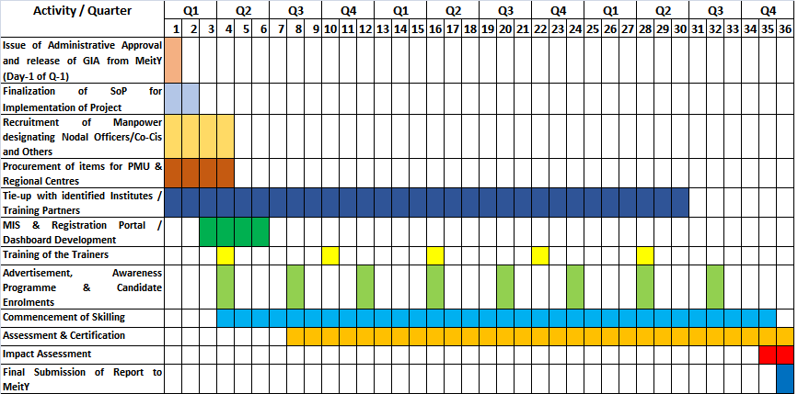

Activities at Training Centre/Training Partner
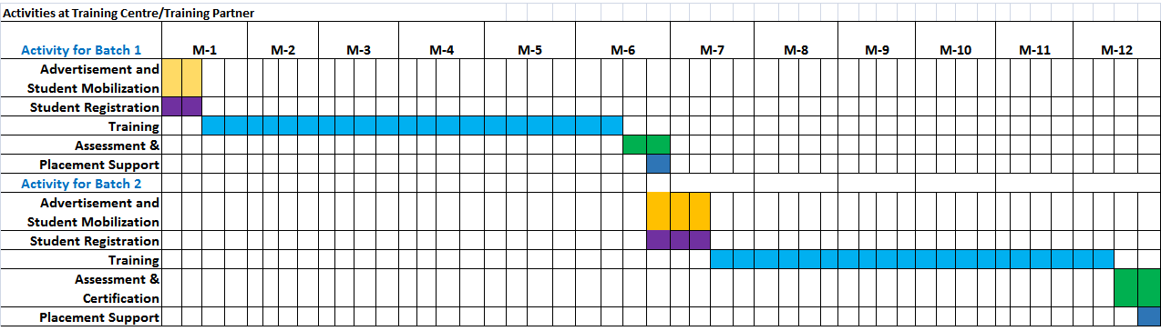
Proposed Skill Development Districts in Odisha

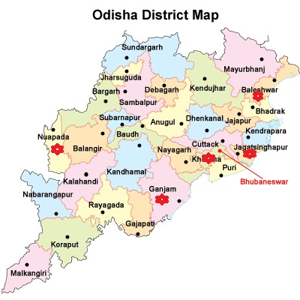
Proposed Locations
Proposed Skill Development Districts in Jharkhand

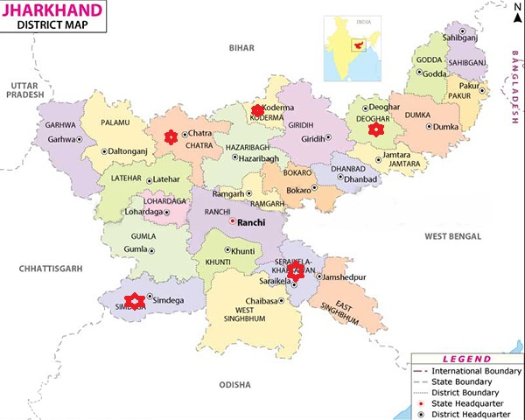

Proposed Locations

Proposed Skill Development Districts in West Bengal

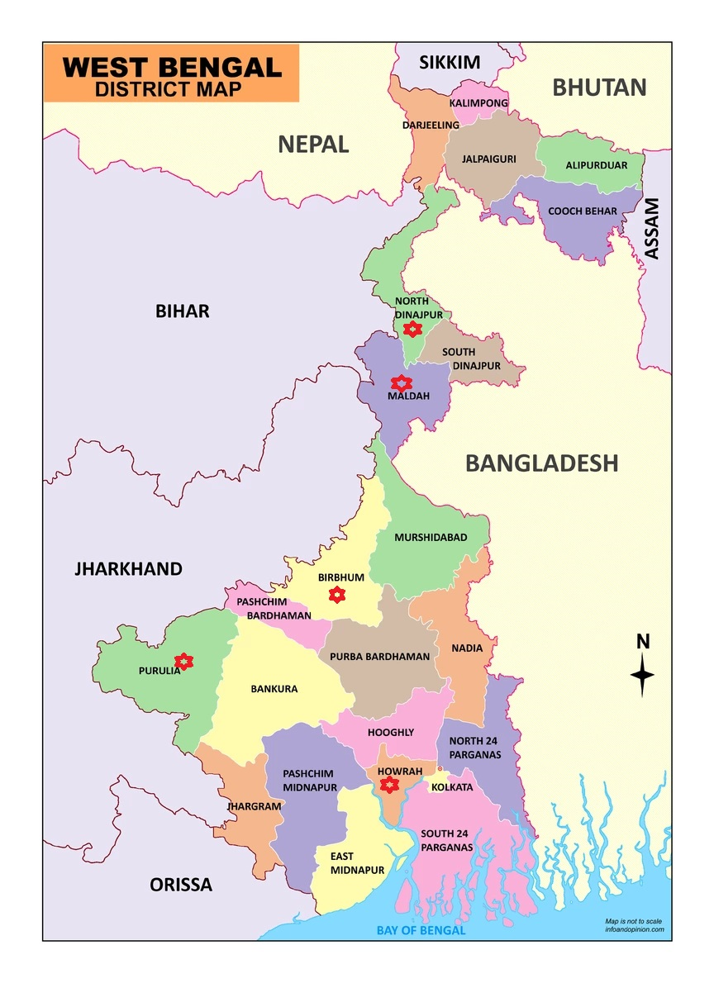
Proposed Locations

Proposed Skill Development Districts in Bihar

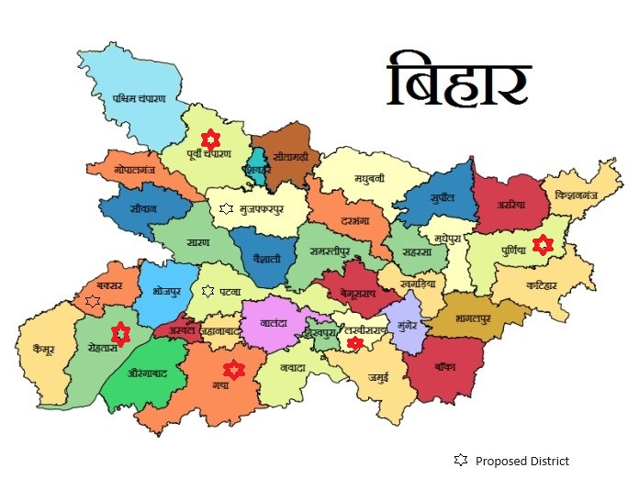

Collaborations and association of NIELIT centres in the States

(Additional Information required)

- Whether the Project Proposal has the approval of the Competent Authority (Other than MeitY societies).
Not applicable as NIELIT being an autonomous Scientific Society of MeitY

- Brief History of Implementing Agency including similar projects done in past, achievements, capabilities etc. may be provided (including recent company reports or Company Brochures):

  - NIELIT Bhubaneswar is executing SC/ST Job seekers project of Directorate General of Employment since 2018 –in year 2022, 375 candidates have been enrolled.
  - NIELIT Bhubaneswar is executing Aspirational District Project having SC/ST & EWS(Women) – 240 candidates enrolled, 120 in process, 360 more in pipeline
  - NIELIT Bhubaneswar is also executing SC-ST/TSP Scheme – 160+ enrolled so far
  - NIELIT Ranchi has completed training of 600 candidates under the project “IT Based Skill Development for SC/ST Candidates” in ten districts of Jharkhand.
  - NIELIT Ranchi is executing SC/ST Job seekers project of Directorate General of Employment since 2014 – in year 2022, 400 candidates have been enrolled.
  - NIELIT Ranchi is executing Aspirational District Project having SC/ST & EWS(Women) in ten districts of Jharkhand – 465 candidates trained, 310 are undergoing training
  - NIELIT Ranchi is also executing SC-ST/TSP Scheme for the benefit of SC/ ST candidates.
  - NIELIT Ranchi has also received approval to train 780 SC/ST candidates in Ranchi which is sponsored by NSSH, Ministry of MSME.
  - NIELIT Kolkata has already executed projects (empowerment of SC/ST/ Youth) at the districts of Cooch Behar, Alipurduar, and Darjeeling funded by MeitY
  - NIELIT Kolkata has already executed projects (empowerment of SC/ST/ Youth) at the districts of Cooch Behar funded by GoWB.
  - NIELIT Kolkata is executing SC/ST job seekers project of Directorate General of Employment since 2010. In last financial year 250 candidates have been trained (200 IT-O level, 50 CHM O level)
  - NIELIT Kolkata is also executing SC-ST/TSP scheme – 6568 trained since last 6 years.
  - NIELIT Patna executed Employee Training Program (ETP) of Bihar Govt. Employees and achieved a target of 18364
  - NIELIT Patna is executing Skill Development of youths in Aspirational Districts in IECT leading to enhancement in Employability, target achieved till now 737.
  - NIELIT Patna executed Kaushal vikas sponsored by department of industries, Bihar and achieved a target of 736.
  - NIELIT Patna executed eGovernance, Department of Information Technology, Govt. of Bihar project and achieved a target of 4179.
  - NIELIT Patna executed Training of Bihar Police officials and Law Enforcement agency, Govt. of Bihar and achieved a target of 4714.

- Any other information in support of the Proposal:
Some part of Odisha, Jharkhand, West Bengal and Bihar are the backward and therefore to cater those parts of the state, this instant project is proposed at NIELIT Bhubaneswar, NIELIT Ranchi, NIELIT Kolkata and NIELIT Patna centre, as well as other locations NIELIT Bhubaneswar, NIELIT Ranchi, NIELIT Kolkata and NIELIT Patna are in process of opening Sub-Centres at various parts of the respective states at the Space available with STPI/ Govt. Polytechnic/ ITI/ Hostels/ Colleges/ Private organizations or Institutes etc., wherever possible.

- Bank Details :
Odisha
  - Bank Name &Code: Bank of India
  - Branch Address: Star House 1/1 D, Jayadev Vihar, Bhubaneswar-751015
  - Account no & Type: 556410110008541
  - IFSC Code: BKID0005564
  - MICR Number: 751013009

- An undertaking has to be given by implementing agencies along with approval

Signature of Chief Investigator Signature of Head of Institution

Name: Jayanta Chakraborty Name:
Designation: Director-in-charge Designation:
Date: Date:

Undertaking

In reference to the proposed project of “Skill Development of unemployed youths of Odisha, Jharkhand, West Bengal, and Bihar for Enhancing Employability and enabling Entrepreneurship towards a Sustainable Developed States” the following is being undertaken:
a) The project, on completion, will be taken over by NIELIT Bhubaneswar, NIELIT Ranchi, NIELIT Kolkata and NIELIT Patna centre with no financial support from Ministry of Electronics & Information Technology (MeitY), Govt. of India
b) NIELIT Bhubaneswar, NIELIT Ranchi, NIELIT Kolkata and NIELIT Patna centre will abide by the Central Vigilance Commission Guidelines.
c) The terms & conditions of the Granting Aid will be strictly adhered to.
d) Co-CI, Bhubaneswar will take the responsibility of implementation of the project as CI, if CI of the project is unavailable.

Signature of Chief Investigator Signature of Head of Institution

Name: Jayanta Chakraborty Name:
Designation: Director-in-charge Designation:
Date: Date:

Annexure-I

Sl No | Name of the Course | Link to Qualification file on National Qualification Register
1 | Product Assembly Assistant (Solar-LED) | Will be available soon
2 | O Level (IT) | https://www.nqr.gov.in/qualifications/3063
3 | Foundation course in Machine Learning using Python | https://www.nqr.gov.in/qualifications/2702
4 | Foundation course in Internet of Things(IoT) | https://www.nqr.gov.in/qualifications/2700
5 | Certified Computer Application Accounting and Publishing Assistant | https://www.nqr.gov.in/qualifications/3406
6 | Certified Web Developer | https://www.nqr.gov.in/qualifications/2723
7 | Certified Data Entry and Office Assistant (Upskilling) | https://www.nqr.gov.in/qualifications/3407
8 | Foundation course in Information Security | https://www.nqr.gov.in/qualifications/2699

- Link to bucket of NSQF NIELIT courses:
https://nielit.gov.in/content/nsqf

Annexure-II
Sl No | Name of the Course | Requirement/availability of the infrastructures and equipment for the practical of the course
1 | Product Assembly Assistant (Solar-LED) | - LED Light strips, multimeter, tester, LCR meter, power analyser, repairing tools.  - Sample of escalation matrix, organisation structure.  - safety glasses, head protection, rubber gloves, safety footwear, warning signs and tapes, fire extinguisher, first aid kit, fire extinguishers and warning signs.  - Personal Protection Equipment: safety glasses, head protection, rubber gloves, safety footwear, warning signs and tapes, fire extinguisher, first aid kit, fire extinguishers and warning signs.  - Solar panel, screw driver, multimeter, tester, pliers, spanner, inverters.  - power analyzer, repairing tools, Sample of escalation matrix, organization structure.
2 | O Level (IT) | • MS-Office Software License  - Text editor software (any One): Notepad++/Sublime text / Visual Studio Code etc.  - Other Software: WAMP/LAMP/XAMP/MAMP etc  - Adobe InDesign, Adobe Photoshop, Python 3  - IOT devices: Sensors, Actuators and Microcontrollers  - Windows / Linux operating system
3 | Foundation course in Machine Learning using Python | - Necessary software, including Python, Jupyter notebooks, and popular machine learning libraries like scikit-learn, TensorFlow, and PyTorch.
4 | Foundation course in Internet of Things(IoT) | - IoT development kits, such as Arduino or Raspberry Pi, with sensors, actuators, and communication modules
5 | Certified Computer Application Accounting and Publishing Assistant | - Microsoft-Office, Tally. ERP 9  - Adobe InDesign, Adobe Photoshop  - Corel Draw, Adobe Flash  - Windows 10 or Above  - Antivirus latest
6 | Certified Web Developer | - MS-Office Software License  - Text editor software (any One): Notepad++/Sublime text/ Visual Studio Code etc.  - Other Software: WAMP/LAMP/XAMP/MAMP etc  - Windows / Linux operating system
7 | Certified Data Entry and Office Assistant (Upskilling) | - Typing Master, Libre Office,  - GUI based Operating System
8 | Foundation course in Information Security | - A Foundation course in Information Security should have a lab infrastructure comprising dedicated computers, servers, and network equipment. Virtualization is essential for creating diverse operating system environments.  - Security tools like antivirus, vulnerability assessment, penetration testing, and network monitoring software are crucial for hands-on experience.  - Additionally, web applications, databases, Active Directory, role-based access control, and proper documentation should be included to cover a wide range of security topics.

Annexure-III

Course fee details (in Rupees)

Course | Duration | No of candidates/ District in 3 years | Total candidates in 4 states (i.e., 20 districts) in 3 years | No of batches in 4 states in 3 years (1 batch =30 student) | Total no of hours | Training expenditure fee/ candidate * | Total Course Fee for all the candidates
Product Assembly Assistant (Solar-LED) | 330 | 240 | 4800 | 160 | 52800 | 12927 | 62050072
O Level (IT) | 540 | 90 | 1800 | 60 | 32400 | 21153 | 38076181
Foundation course in Machine Learning using Python | 90 | 570 | 11400 | 380 | 34200 | 3526 | 40191524
Foundation course in Internet of Things(IoT) | 90 | 360 | 7200 | 240 | 21600 | 3526 | 25384120
Certified Computer Application Accounting and Publishing Assistant | 360 | 210 | 4200 | 140 | 50400 | 14102 | 59229614
Certified Web Developer | 210 | 240 | 4800 | 160 | 33600 | 8226 | 39486410
Certified Data Entry and Office Assistant (Upskilling) | 210 | 360 | 7200 | 240 | 50400 | 8226 | 59229614
Foundation course in Information Security | 90 | 432 | 8640 | 288 | 25920 | 3526 | 30460945
TOTAL |  | 2502 | 50040 | 1668 |  |  | 35,41,08,480  (3541.08 lakh)

* The training expenditure fee includes registration fee of the candidates and excludes assessment fee
- District wise 2502 candidates (i.e., 84 batches each containing 30 students) will be trained in 3 years.

Annexure-IV

Sl. No | Prospective Employer | Skill Preferred by the Employer
1 | Tata Consultancy Services | Basic Computer Skill (Internet, Web Design, etc.), Communication Skill
2 | Tech Mahindra | Basic Computer Skill (Internet, Web Design, etc.), Communication Skill
3 | Gradients Staffing Pvt Ltd | Basic Computer Skill, Communication Skill
4 | Sureworks Infotech Pvt.Ltd | Computer Hardware & Networking, Cybersecurity
5 | Printlink Computer & Communication Pvt.Ltd | Computer Hardware & Networking
6 | Computronics Multivison Pvt.Ltd | Computer & Laptop Servicing
7 | Indian Hobby Centre | IOT & Drones
8 | Secuodsoft Technology | Web Development & Software Development
9 | Cliverware Pvt.Ltd | Software Development
10 | Softech ERP Solutions Pvt. Ltd. | Software Development
11 | ITM SKILLS ACADEMY | Basic Computer Skill (Internet, Web Design, etc.), Communication Skill
12 | SigiloTech | Software Development
13 | S &IB Services Pvt. Ltd. | Computer Hardware & Networking, Software Development
14 | Taurus BPO | Basic Computer Skill, Communication Skill
15 | Hdb financial services Ltd | Basic Computer Skill, Communication Skill
16 | BAJAJ CAPITAL INSURANCE BROKING LTD. | Basic Computer Skill, Communication Skill
17 | Writer Information and Business Services | Computer Hardware & Networking, Software Development
18 | Pace Setters Business Solutions Pvt.Ltd. | Training and Development, Analytics
19 | LabourNet Managed Services Pvt.Ltd | Basic Computer Skill, Communication Skill, Analytics
20 | Bazar Kolkata | Basic Computer Skill, Communication Skill, Analytics
21 | Tatwa Technologies | Computer Hardware & Networking, Software Development, Cloud computing
22 | Fusion BPO | Basic Computer Skill, Communication Skill
23 | Mpokket Pvt Ltd | Basic Computer Skill, Communication Skill, Analytics

Annexure-V

Placement, Employment & Entrepreneurship:

Tie-up with companies for placement support in the state of Odisha, West Bengal, Jharkhand, and Bihar

NIELIT Ranchi Centre in state of Jharkhand
S. No. | Company Name
1 | HipHop Media House PVT.LTD
2 | Best Job
3 | PayTm Services
4 | ICICI Foundation
5 | Aajivika Global Skill Pvt Ltd
6 | Sidhi Vinayak Academy
7 | Aerosoft HealthCare Pvt Ltd
8 | HDB Financial Services LTD
9 | DYLIS Business Services PVT LTD
10 | Career Foundation
NIELIT Kolkata in state of West Bengal
S. No. | Company Name
1 | ITM SKILLS ACADEMY
2 | BAJAJ CAPITAL INSURANCE BROKING LTD.
3 | Softech ERP Solutions Pvt. Ltd.
4 | SigiloTech
5 | LabourNet Managed Services Pvt.Ltd
6 | Hdb financial services Ltd
7 | Writer Information and Business Services
8 | Gradients Staffing Pvt Ltd
9 | Taurus bpo
10 | S&IB Services Pvt Ltd
11 | Pace Setters Business Solutions Pvt Ltd
12 | Fusion BPO
13 | Mpokket Pvt Ltd
14 | Bazaar Kolkata
15 | KIA MOTORS
16 | CHOLAMANDALAM BANK
17 | PRIVATE SECTOR
18 | STATE ELECTRICITY BOARD
19 | FINANCE DEPT. GOVT. OF WB
20 | EASTERN RAILWAY, DHANBAD
21 | FACULTY AT RAMKRISHNA MISSION, ARUNACHAL PRADESH
22 | MUTHOOT FINANCE, THAKURPUKUR
23 | PRIVATE HARDWARE COMPANY
24 | RESERVE BANK OF INDIA
25 | Tech mahindra
26 | Amazon
27 | Dept of Irrigation
28 | Pinatech Info Sol.
29 | CTS
30 | JR Infotech
31 | TCS - Mainframe
32 | PSC clerkship
33 | Bluedart (Wherehouse operation)
34 | Agricultural Executive
35 | FINANCE DEPT. GOVT. OF WB
36 | STATE ELECTRICITY BOARD
37 | KIA MOTORS
38 | CHOLAMANDALAM BANK
39 | Reliance Digital
NIELIT Patna in state of Bihar
S. No. | Company Name
1 | EBIX CASH
2 | MOTHERSON (Royal Services )
3 | SIDDHI INFONET INDIA PVT.LTD.
4 | AKSHARAM AJIT
5 | TATA MOTORS
6 | BAJAJ AUTO
7 | RSB, TRANSMISSOIN
8 | PAYTM
9 | URBAN MONEY
10 | BAJAJ CAPITAL
11 | KUTUMBH CARE PVT LTD (Dixon Technology )
12 | NHSE PVT
13 | TECH MAHINDRA PVT LTD
14 | CARD EXPERTISE INDIA PVT LTD
15 | HCL
16 | Sirius Computer Solutions
17 | Standard Chartered Bank
18 | Collabera (American MNC)
19 | Microsoft
20 | Wipro
21 | NMDC ltd
22 | Punjab National Bank
23 | Cloudstrats Technologies Pvt ltd
24 | SISA Information Security Pvt. Ltd
25 | FireCompass
26 | TCS Bangalore
27 | Rigel Information Systems, Bangalore
28 | USP Global
29 | Capgemni
30 | United Health Group, Noida
31 | Cyber Forensic Laboratory, Panchkula
32 | AAA technologies pvt ltd
33 | Teqfocus, Pune
34 | TISPL, Gurgaon
35 | IIT Patna incubation Centre
36 | Axis Bank
37 | Icare Infosystem
38 | Cymatic EduTech Private Limited.
39 | iCare Infosystems Pvt. Ltd
40 | Skynet Weather
41 | CSM technology Patna
42 | TISPL
43 | Land and Revenue Department, Bihar
44 | BELTRON
45 | Evelyn Learning
46 | Duranda College
47 | Aqua Sub Engineeing
48 | JEEViKA, Bihta, Bihar
49 | COPA IT Solution , Patna
50 | Infosys System Engineer, Bangalore
51 | Aditya Birla Finance, Siwan
52 | Millenium Electronics , HP
53 | Novel Gene Technology, Hyderabad
54 | Electricity Grid Maintenance, Karnatka
55 | Infinity Construction, Patna
56 | TCS, Kolkatta
57 | Indian Railway, Technician
58 | PG Electroplast
59 | Mehta Cad cam Pvt. Ltd, Ahmedabad
60 | HyperX Energy Pvt. Ltd., Delhi
61 | IT Sector, Pune
62 | TISCO, Jamshedpur
63 | Aaratrika Apparels Pvt. Ltd., Ludhiana
64 | Dept. of Revenue & Land Reforms, Government of Bihar.
65 | SBPDCL, Govt. of Bihar
66 | NSMCH, Bihta
67 | Lifegraph Biomedical Instrumentation Pvt.Ltd, Patna
68 | Hospital(Advance ENT), Bhagalpur
69 | Amoli Organics Pvt. Ltd., Vadodara
70 | Union Bank of India, Panvel, Mumbai
71 | Panchayati Raj Vibhag, Samastipur, Bihar
72 | ESIC Hospital , Bihta
73 | Indian Railway, Loco Pilot
74 | Aishwarya Laxmi Agromart Pvt. Ltd., Patna
75 | Tyagi Induxtries, Patna
76 | Smartway Electronics Pvt., Ltd, Patna
77 | Reliance Pvt. Ltd., Patna
78 | Pathkind Pvt. Ltd, Patna
79 | Supreme Pipe Pvt. Ltd., Gaya, Bihar
80 | IPCA Laboratory, Mumbai
81 | Nagar Parisad, Danapur, Bihar
82 | Unique Identification Authority of India Patna , Office Assistant
83 | Teacher, Government Middle School Meeralipur Begusarai Bihar
84 | Government Middle School Halimpur, Jamalpur, Munger, Bihar
85 | Shipping Corporation of India, Mumbai, Second Officer
86 | Marcs Pvt. Ltd., Patna
87 | Tata Memorial Cancer Hospital, Muzaffarpur
88 | State Bank of India, Paliganj, Patna
89 | Govt. Inter College, Jamania
90 | Eye Care Info System Pvt. Ltd., Patna
91 | Aerial Telecom, Mumbai
92 | PNB, Aurangabad, Bihar
93 | Hindustan Petroleum, Patna
94 | Bank Of India Kodrma Jharkand
95 | P N B Bank Aurangabad Bihar
96 | Income Tax Department
97 | UCO Bank Bharoch Gujrat
98 | ESIC Patna
99 | Minda Kosel Aluminiuam PVT.LTD
NIELIT Bhubneshwar in state of Odisha
S. No. | Compnay Name
1 | Indian Bank
2 | Police Deptt, Odisha
3 | Sarada Systems, Bhubaneswar
4 | Odisha Co-Operative Bank
5 | SBI
6 | Interglobe Enterprises
7 | IBPS, RRB
8 | IoB
9 | Antomy Drone
10 | ASO

All four NIELIT centres i.e. Ranchi & Bhubaneswar, Kolkata and Patna, have a Skill Development & Placement cell which is dedicated for the placement of candidates passing out from the institute. The cell has been instrumental behind creation of employment opportunities through regularly organizing campus/off-campus Placement drives/ RojgarMela for the students of NIELIT centres. The cell will also be working for creation of placement opportunities for the students under the project. The cell is continuously working to have more and more industry linkages for better placement opportunities of candidates.

All four NIELIT Centres are proactively working with the office of Sub Regional Employment Officer a local office of DGE and with the State Government Employment Exchanges for mobilization of candidates and prospective employers during these events.

Industry meets have been organized by the Centres to have tie-ups with the local industries and to understand their need and skill gaps. Also, MoUs are planned to be executed between industry associations like NASSCOM local chapter, Confederation of IT Enterprises, Odisha, ITAO, Utkal Chamber of Commerce to maximize employment opportunities.

NIELIT centres have alliance with Incubation Centre, Industries and corporates. Candidate have option to incubate or start their own work apart from being placed in Industry & Government departments. To enhance the employability, soft-skill components are incorporated in the course of all the proposed courses. NIELIT Bhubaneswar already have MoUs with the following industries / organizations / academia to provide best post training opportunities and more alliances are being added to the basket soon for a wider reach:

a) Sri Sri University, Cuttack

b) Atal Incubation Centre - Nalanda Institute of Technology Foundation, Bhubaneswar

c) Karkhana (Sudolearn Solutions Pvt Ltd), Bhubaneswar

d) Odia Mail Pvt. Ltd, Bhubaneswar

e) Swabalambi Odra Green Farmers Producer Co.Ltd, Bhubaneswar

f)Technohub, Bhubaneswar

NIELIT Kolkata already has MoUs with the following industries / organizations / academia to provide best post training opportunities:

MoU have been signed among C-DAC, NIELIT Kolkata and other NIELIT Centres to conduct training under ‘FutureSkills PRIME–Programme for Re-skilling/Up-skilling of IT Manpower for Employability’ on Blockchain Technology, Big Data Analytics and Virtual/Augmented Reality.

Co-operation agreement signed on 27.07.2020 among GIZ, Skill Council for Green Jobs and NIELIT Kolkata under I-RISE Suryamitra Upskilling Programme on installation, operation, maintenance and entrepreneurship for residential rooftop PV systems.

MoU was signed between NIELIT Kolkata and Larsen & Toubro Construction Skill Training Institute (L&T-CSTI), Serampore, West Bengal on 14th Oct 2019 and it was valid till 13th Oct 2020. It was again extended upto 31st March 2022 for evaluation of the candidates successfully completing the training modules through online/offline examination mode and provide training certificates to the successful candidates and L&T-CSTI Serampore agreed for arranging the infrastructure requirements arranging computer Lab and faculty for completing the training module.

With Jadavpur University on 08.03.2020 for offering job-oriented courses in state-of-the-art subjects in diverse areas including engineering and technology.

With Directorate of Electricity, Govt of West Bengal for AMC for License Monitoring System.

Agreement was signed between NIELIT Kolkata and West Bengal Electronics Industry Development Corporation (WBEIDC) Limited, GoWB for Skilling youth in and around IT Parks at Bolpur, Kharagpur, Barjora, Asansol, Purulia, Siliguri on 4thApril 2018 and it was valid till 3rd April 2021. NIELIT Kolkata was also agreed to conduct Skill Development and Digital Literacy Training program for local youth in and around 6 IT parks.50% course fees of the successful candidates were sponsored by WBEIDC.

With Public Service Commission (PSC), Govt of West Bengal for Development of Website & Implementation of Online Recruitment Portal of PSC, Govt of West Bengal and Maintenance of the portal.

NIELIT Kolkata has signed a MoU with Steel Authority of India Limited, Govt of India on 12.04.2018 for Maintenance of Legacy Application Software Modules at SAIL-ISP, Burnpur.

An MoU has been signed with Dept of Agriculture & Farmers Welfare(DA&FW), Ministry of Agriculture, GoI towards execution of the Agriculture Census 2020-21 project with total outlay of Rs.13.52 crore for 3.5 years on 17.02.2022 in the office of DA&FW, New Delhi.

NIELIT Kolkata signed a Memorandum of Agreement (MoA) with Thadomal Shahani Engineering College (TSEC), Advocate Nari Gursahani Marg, 37th Road, (Off Linking Road), TPS III, Bandra (west), Mumbai-400050 on 29.07.2022. The objective of the MoA is to engage the institute as spoke. As per this MoA, TSEC will mobilize and impart training to 500 beneficiaries in bridge course (90 hours) of Blockchain Technology. NIELIT Kolkata will provide the requisite training of TSEC faculties under Training of Trainers (ToT) scheme and provide online infrastructure through LMS portal for conducting the bridge course in blended mode.

NIELIT Kolkata signed a Memorandum of Agreement (MoA) with Netaji Subhash Engineering College(NSEC), Techno City, Panchpota. Garia, Kolkata-700152, on 15.11.2022. The objective of the MoA is to engage the institute as spoke. As per this MoA, NSEC will mobilize and impart training to 500 beneficiaries in bridge course (90 hours) of Blockchain Technology. NIELIT Kolkata will provide the requisite training of NSEC faculties under Training of Trainers (ToT) scheme and provide online infrastructure through LMS portal for conducting the bridge course in blended mode.

NIELIT Kolkata signed a Memorandum of Agreement (MoA) with Rail Edutech Private Limited (REPL), B-8, Sector 2, Noida 201301, on 01.03.2023. The objective of the MoA is to engage the institute as spoke. As per this MoA, REPL will mobilize and impart training to 500 beneficiaries in bridge course (90 hours) of Blockchain Technology. NIELIT Kolkata will provide the requisite training of REPL faculties under Training of Trainers (ToT) scheme and provide online infrastructure through LMS portal for conducting the bridge course in blended mode.

All the proposed courses have Employability Skills / Soft Skills as part of their curriculum. Specialized Skill Development / OJT will also be conducted at Industry locations/ concerned departments & Institutes of the related trade.

Course wise employment opportunities are as under:

Sr No | Course Name | Employment Avenues
1 | Product Assembly Assistant (Solar-LED) | With the cutting edge technology, Solar & LED Lighting Product are high in demand. Candidates have option to start their own start-ups & become entrepreneurs. Also they have option to get employed by the industries working in this domain as energy sector is always in high demand and there is good demand of skilled manpower both in design / manufacturing & maintenance / repair.
2 | O Level (IT) | State Govt. recognized NIELIT ‘O’ Level as one of prerequisite for various state Government Jobs. Not only in the state, many other states as well as Central Government jobs and PSUs are also recognizing the program and qualification is being asked as a prerequisite. Candidate will have option to get absorbed into Government jobs. Apart from the Government jobs, industry also recognizes the qualification as well as candidate will have option to start their own ventures. In the state of Odisha, it is recognized as equivalent to DCA/PGDCA.
3 | Foundation course in Machine Learning using Python | A Foundation Course in Machine Learning using Python can lead to careers in data analysis, machine learning engineering, and artificial intelligence. Graduates with this foundation often find opportunities in industries such as healthcare, finance, and technology, with roles like data analyst, machine learning engineer, or AI researcher. This course equips individuals with essential skills to work on machine learning projects and apply data-driven solutions.
4 | Foundation course in Internet of Things(IoT) | A Foundation Course in Internet of Things (IoT) can open doors to careers as IoT developers, solution architects, and IoT project managers. Graduates are in demand across industries like smart manufacturing, healthcare, and agriculture, where IoT skills are essential for designing and implementing IoT solutions. This course equips individuals with the knowledge to create and manage IoT systems, making them valuable in a variety of professional settings.
5 | Certified Computer Application Accounting and Publishing Assistant | Candidate will have option to build carrier in accounting using tally, office automation or even in Desktop Publishing area. A lot of Government & corporate jobs are available for skilled people, not limited to the job, candidates have option to start their own setup and may provide multiple service under one single umbrella.
6 | Certified Web Developer | Now a days, everyone is looking for web based solutions for their business, irrespective of a small store owner or a large corporate. Good web developers are very high in demand. Candidates may start their own web development company or may get employment at other such companies, corporates, MNCs and even in Government Sectors.
7 | Certified Data Entry and Office Assistant (Upskilling) | Candidate will have option to build carrier in Data entry & office automation. A lot of Government & corporate jobs even online jobs are available for such peoples. Candidates may also start their own setup and provide multiple services under one single umbrella. These skilled candidates are high in demand in as part time and even job work basis employment at differ offices, lawyers, Publishers, content writers etc.
8 | Foundation course in Information Security | Upon completing a Foundation course in Information Security, individuals can explore various employment avenues in the field. They can pursue entry-level roles such as Information Security Analysts, where they monitor and protect an organization's systems and data. Security Consultants are another option, offering advisory services to businesses on improving their security measures. Cybersecurity Technician positions focus on the installation and maintenance of security systems, while Risk Analysts assess and manage security risks for organizations, helping them make informed decisions to mitigate potential threats.

Furthermore, NIELIT has Model Career Centre (MCC), and Industry linkage which will be utilized for placement opportunities to the students.

The National Career Service (NCS) Project has envisaged setting up of Model Career Centres (MCCs), a brick and mortar model of NCS, which have state-of-the-art infrastructure and will act as a hub of career counselling and also provide career related services such as organising job fairs, mobilise the employers, provide career counselling at local level etc. in collaboration with States and other institutions to the jobseekers and employers through outreach activities.

As of now, Model Career Centre are established at 07 locations of NIELIT viz. Aurangabad, Calicut, Gorakhpur, Imphal, Kolkata, Leh and Srinagar in collaboration with National Career Service Centres of Directorate General of Employment which are conducting job fairs regularly. NIELIT is constantly putting up various efforts for placing its candidates.

Recognition of O Level is available at https://www.nielit.gov.in/content/o-level-recognition.

Recognition and equivalence details of O Level is given below:

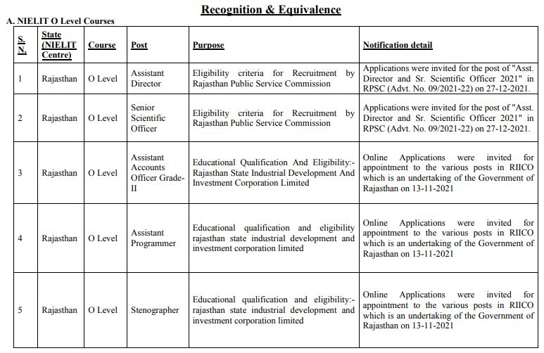

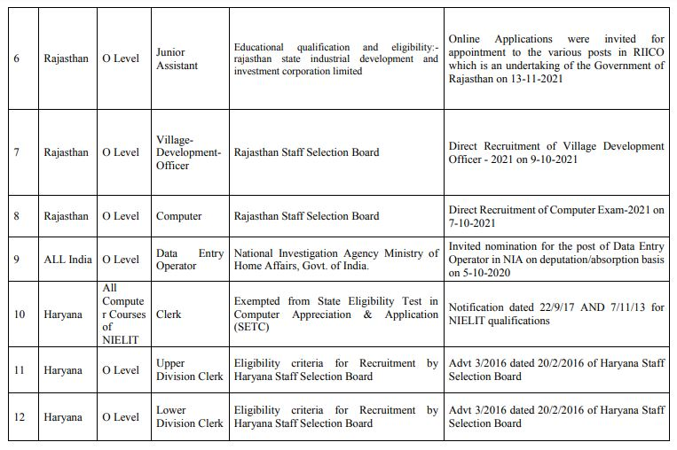

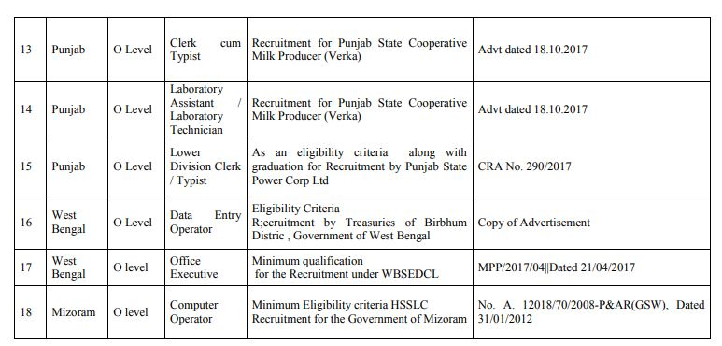

Annexure VI

Support letter of state government

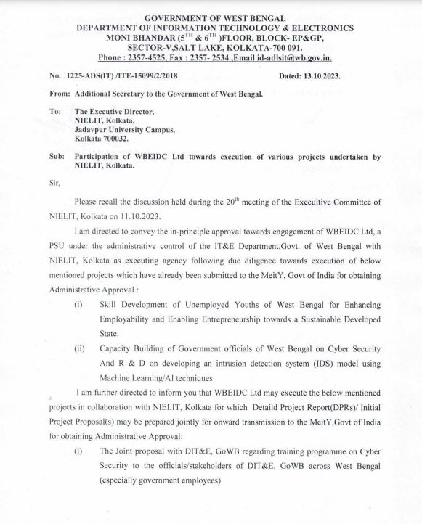

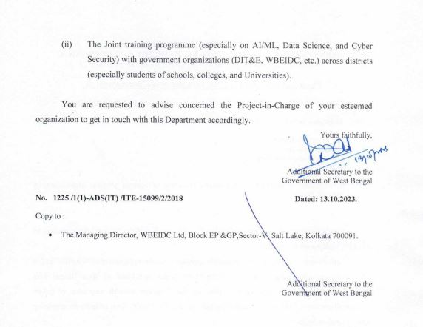

Annexure-A

Details of Budget

Infrastructure cost (PMU):
Table –A1
Infrastructure Cost PMU (in Rupees)
Sl No | Equipment | Unit Cost (INR) | Unit required | Year-I (A) | Year-II (Maintenance cost B= 10 % of A) | Year-III (Maintenance cost C= 10% of A) | Total
1 | Laptop (I7) | 120000 | 4 | 480000 | 48000 | 48000 | 576000
2 | Dekstop (I7) | 88000 | 2 | 176000 | 17600 | 17600 | 211200
3 | Printer | 50000 | 2 | 100000 | 10000 | 10000 | 120000
4 | Furniture | 300000 | 1 set | 300000 | 0 | 0 | 300000
5 | UPS, Networking, and Accessories | 560000 | 1 set | 560000 | 0 | 0 | 560000
 | Total (rounded off) |  |  | 16,16,000  (16.16 lakh) | 75,600  (0.756 lakh) | 75,600  (0.756 lakh) | 17,67,200  (17.67 lakh)
 |  |  |  |  |  | Total | 17,67,200  (17.67 lakh)

Note: Two laptops have been kept for CI and Co-CI at NIELIT Bhuneshwar

Infrastructure cost (Regional Co-ordination Unit)
Table –A2
Infrastructure Cost at Regional Co-ordination unit (in Rupees)
Sl No | Equipment | Unit Cost (INR) | Unit required | Year-I (A) | Year-II (Maintenance cost B= 10 % of A) | Year-III (Maintenance cost C= 10% of A) | Total
1 | Laptop (I7) | 120000 | 6 | 720000 | 72000 | 72000 | 864000
2 | Dekstop (I7) | 88000 | 3 | 264000 | 26400 | 26400 | 316800
3 | Printer | 50000 | 3 | 150000 | 15000 | 15000 | 180000
4 | Furniture | 300000 | 3 | 900000 | 0 | 0 | 900000
5 | AC | 50000 | 3 | 150000 | 15000 | 15000 | 180000
 | Total (rounded off) |  |  | 21,84,000  (21.84 lakh) | 1,28,400  (1.284 lakh) | 1,28,400  (1.284 lakh) | 24,40,800  (24.41 lakh)
 |  |  |  |  |  | Total | 24,40,800  (24.41 lakh)

Note: Three laptops have been kept for all three Co-CIs at NIELIT Patna , Kolkata and Ranchi

Training expenditure
Table –A3

Training expenditure (in Rupees)
Heads | Total Fund | Year-I | Year-II | Year-III | Remarks
Expenses towards infrastructure (internet facility, electricity, water, Sanitation, cleaning & Security etc. ) | 28800000 | 9600000 | 9600000 | 9600000 | 2 lakh per state x 4 states, per month as per below:  - Broadband connection: Rs. 50K (10K x 5 districts).  - Rent: Rs. 125K (25K x 5 districts).  - Electricity, security, cleaning, etc: Rs. 25K (5K x 5 districts).
Faculty (see Table A4 for details) | 285348480 | 86208000 | 94828800 | 104311680 | See Table A4 for details.
Training of Trainers | 3960000 | 3960000 | 0 | 0 | 66 nos @ 15K x 4 states  - Training Fee: Rs. 13K- ToT is 100 hours course as per Future Skill practice. Per hour rate @ Rs. 130/-.  - Study material and training kit: 2K per candidate.
Expenses towards lab and office consumables | 28800000 | 9600000 | 9600000 | 9600000 | 2 lakh x 12 months x 4 states as per below:  - Items such as components (namely solar, led, IoT devices, Rasbery-pi, ardruino, breadboard, etc.) used in the lab: Rs. 50K (10K x 5 districts)  - A4 paper, stationary items etc: Rs. 150K (30K x 5 districts).
Conduction of Rojgar mela, Job fair | 7200000 | 2400000 | 2400000 | 2400000 | This initiative is required to create job awareness, job employment, and engagement of local youths in the districts. This awareness creation will help to motivate the local youth and will also attract the industry to know the availability of the skilled manpower. This expenditure could be made to bridge the gap.  3 Lakh X 2 times X 4 states as per below:  - Job fair: Rs. 2 lakh (40K x 5 districts) half-yearly basis.  - Rojgar mela: Rs. 1 lakh (20K x 5 districts) half-yearly basis.
Total  (rounded off) | 35,41,08,480  (3541.08 lakh) | 11,17,68,000  (1117.68 lakh) | 11,64,28,800  (1164.29 lakh) | 12,59,11,680  (1259.12 lakh)

Table –A4
Faculty (each state) (in Rupees)
Designation of post | Monthly salary | No. of Posts | Year-I (A) | Year-II (B=A*1.1) | Year- III  (C= B*1.1) | Total Expenditure in 3 Years
IT Faculty | 40000 | 15 | 7200000 | 7920000 | 8712000 | 23832000
Electronics Faculty | 42000 | 7 | 3528000 | 3880800 | 4268880 | 11677680
IT Lab Assistant | 20500 | 30 | 7380000 | 8118000 | 8929800 | 24427800
Electronics Lab Assistant | 20500 | 14 | 3444000 | 3788400 | 4167240 | 11399640
 | Total  (rounded off) | 66 | 2,15,52,000  (215.52 lakh) | 2,37,07,200  (237.07 lakh) | 2,60,77,920  (260.78 lakh) | 7,13,37,120  (713.37 lakh)

Certification and assessment cost
Table –A5

Certification and Assessment Cost (in Rupees)
Courses (A) | Total Candidates/ state (B) | Total no of paper (C) | Cost per paper as per NSQF norms (D) | Certification & Assessment Cost + within NSQF norm (E) =C x D | Certification & Assessment Cost (F) = B x E
Sl no 1,5,6,7 of Table I | 5,250 | 1 | 1534/- per paper per candidate | Rs 1534/- per candidate | 80,53,500
S no 3,4 and 8 of Table I | 6,810 | 1 | Rs 944/- per paper per candidate | Rs 944/- per candidate | 64,28,640
Sl no 2 of Table I | 450 | 4 | Rs. 1416/ per paper per candidate * | Rs. 1416/ x 4 = Rs 5,664/- per candidate* | 25,48,800
 |  | Total/ state (rounded off) |  |  | 1,70,30,940  (170.31 lakh)
 |  | Total in 4 states (rounded off) |  |  | 6,81,23,760  (681.24 lakh)

E = C x D and F = B x E

+ As per NIELIT NSQF examination fee including applicable GST. Please refer https://www.nielit.gov.in/sites/default/files/headquarter/pdf/Section_E_032022.pdf

* Considering modular assessment and certification will be made for each of the four modules of O level (IT)

Note:

1. O level (IT) being a non-formal course, the registration, examination and certification process will be different from other course mentioned above, and the guidelines framed by NIELIT for non-formal courses will be followed.

2. O level (IT) is having provision of modular certification, and the candidate may avail it after completion of each module.
Customization & Integration of Dashbaord with existing MIS portal at HQ for project management: Cloud based dashboard, which include charges toward customization of existing MIS , development of new dashboard application and cloud space for the dashboard application and student records. Detail cost break-up is given below:
Table –A6
Component | Cost (In Lakh)
Requirement analysis | 1
Data Collection and refining | 2
Dashboard Design | 5
Application Development (including SSL integration and security audit) | 9
Testing | 1
User Training & Implementation | 1
Material Preparations | 1
Maintenance (7.5%) | 1.5 – 2nd year and 1.5 – 3rd year

Manpower Cost (PMU)
Table –A7
Manpower Cost PMU (in Rupees)
Sl No | Designation | NO (A) | Salaries per month in Rs (B) | Year-I (C=A*B*12) | Year-II (D= 110% of C) | Year-III (E= 110% of D) | Total
1 | Project co-ordinator | 1 | 80000 | 960000 | 1056000 | 1161600 | 3177600
2 | Resource Person (Admin. & Finance) | 1 | 50000 | 600000 | 660000 | 726000 | 1986000
3 | Resource Person(Office Assistant) | 2 | 44000 | 1056000 | 1161600 | 1277760 | 3495360
4 | Resource Person (NIELIT HQ) | 1 | 50000 | 600000 | 660000 | 726000 | 1986000
 | Total (rounded off) |  |  | 32,16,000  (32.16 lakh) | 35,37,600  (35.38 lakh) | 38,91,360  (38.91 lakh) | 1,06,44,960  (106.45 lakh)

Manpower Cost (Regional co-ordination Unit)
Table –A8
Sl No | Designation | NO (A) | Salaries per month in Rs (B) | Year-I (C=A*B*12) | Year-II  (D= 110% of C) | Year-III (E= 110% of D) | Total
1 | Regional Co-ordinator | 3 | 55000 | 1980000 | 2178000 | 2395800 | 6553800
2 | Resource Person (Office Assistant) | 3 | 34000 | 1224000 | 1346400 | 1481040 | 4051440
 | Total (rounded off) |  |  | 32,04,000  (32.04 lakh) | 35,24,400  (35.24 lakh) | 38,76,840  (38.77 lakh) | 1,06,05,240  (106.05 lakh)

Travelling expenses toward monitoring of the project
Table –A9
Travelling expenses details (INR)
Description | Amount per district | No of District | No of Visit monthly | 1st Year | 2nd Year | 3rd Year | Total
Travelling Expenses for projects monitoring | 7500 | 20 | 1 | 1800000 | 1800000 | 1800000 | 5400000
Total (rounded off) |  |  |  | 1800000  (18 lakh) | 1800000  (18 lakh) | 1800000  (18 lakh) | 5400000  (54 lakh)

Advertisement & Publicity

Rs. 2.5/- lakh per district per year for 4 states i.e. Rs. 62500 /- only per year for each district for one state considering two times advertisement in a year as per DAVP rate. Furthermore, publicity through posting at social media, website, distribution of leaflets /posters /banners, and direct counseling at educational institutions. Break-up detail is as follows:

Table –A10

Advertisement expenses details (INR)
Descriptions | Amount(Rs.) per District | No of District | Half yearly | News Paper | 1st Year | 2nd Year | 3rd Year | Total | Remarks
Advertisement | 23808 | 20 | 2 | 4 | 3809280 | 3809280 | 3809280 | 11427840 | 42cm X 36 cm
social media, website, distribution of leaflets / posters / banners, and direct counseling at educational |  |  |  |  | 1190720 | 1190720 | 1190720 | 3572160
Total (rounded off) |  |  |  |  | 5000000  (50 lakh) | 5000000  (50 lakh) | 5000000  (50 lakh) | 15000000  (150 lakh)

Impact Assessment: Impact Assessment will be done to analyse the impact of the project on ground @Rs. 5 lakh/- per state and it will be carried out in the 3rd year.

Administrative Overhead cum Project management fees

Table –A11
Administrative Overhead cum Project management fees (INR)
 | Description | Amount(Rs.) | No of District | 1st Year | 2nd Year | 3rd Year | Total
1 | Tendering process | 80000 | 20 | 1600000 | 1600000 | 1600000 | 4800000
2 | Inspection charges | 70000 | 20 | 1400000 | 1400000 | 1400000 | 4200000
3 | Storage Cost | 60000 | 20 | 1200000 | 1200000 | 1200000 | 3600000
4 | Supply & installation | 70000 | 20 | 1400000 | 1400000 | 1400000 | 4200000
5 | Invoice processing | 45000 | 20 | 900000 | 900000 | 900000 | 2700000
6 | Others Administrative and project management |  |  | 984796 | 1157436 | 1766890 | 3909122
Total (rounded off) |  |  |  | 7484796  (74.85 lakh) | 7657436  (76.57 lakh) | 8266890  (82.67 lakh) | 23409122  (234.09 lakh)

Contingency and Miscellaneous

Table –A12

Contingency and Miscellaneous (INR)
Descriptions | 1st Year | 2nd Year | 3rd Year
Contingency
Office automation equipment | 504000 | 504000 | 504000
Cartridge of photocopiers, printers, copying machines, | 860000 | 1080000 | 1250000
Filing and indexing systems, Xerox Paper, etc | 209260 | 389260 | 619260
Total (rounded off) | 1573260  (15.73 lakh) | 1973260  (19.73 lakh) | 2373260  (23.73 lakh)
Miscellaneous
Books, periodical | 360000 | 360000 | 360000
Magazines | 180000 | 180000 | 180000
postage | 108000 | 108000 | 108000
Expenditure on organization/ participation seminars | 625260 | 1025260 | 1425260
Audit\ Legal fees (Yearly) | 300000 | 300000 | 300000
Total (rounded off) | 1573260  (15.73 lakh) | 1973260  (19.73 lakh) | 2373260  (23.73 lakh)

